Renju lesson on March 22, 2001

Hello all! Welcome to Online Renju Class. Today we will continue with d11 opening. Last week we learned about the 5-f8. The variant we played last time ended with black win. Today we will try another 16th move and prove white win there – that is the new style. Can you guess where is it? Who, most of you know f9.
I will show you some strong black defenses. And we will try to find win.
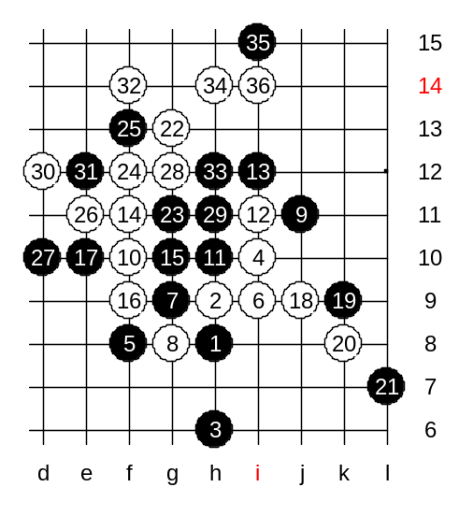
We begin with 17-e10. Since white does not have VCT, white must develop carefully. Congratulation to those who guessed j9 to be next white move. Black’s next move (k9) is forced. White plays k8… Why? Who can explain? Use the general concept. Why k8 is the only way to win? (for example, h11 doesn’t win).
The answer is following: White uses three, to force black to block below (otherwise easy win), and then white can create VCF threat above, at g13. Thanks to k8 stone, white f-line becomes more alive.

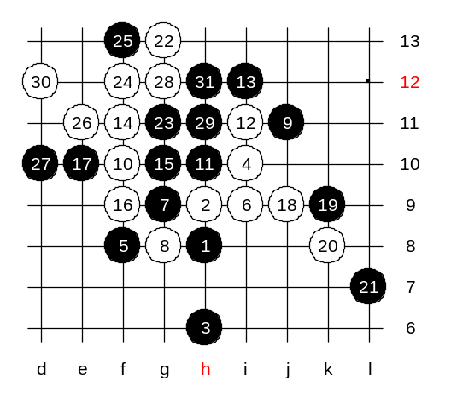
We will show one of the example wins.

Another 31st move.
This is the medium level homework. Please find the white win.

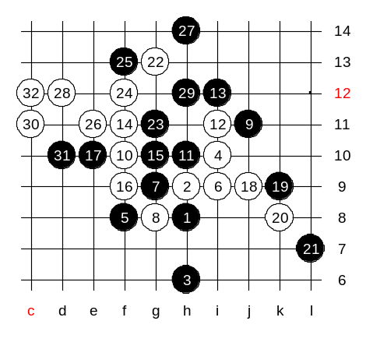

We try another 27th move now.

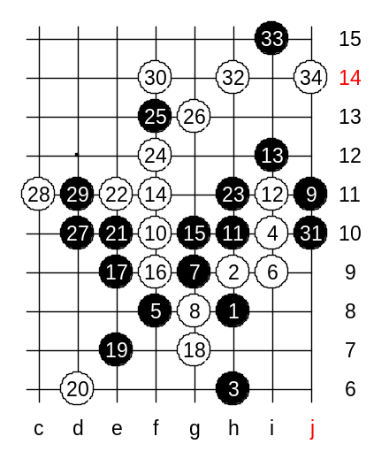

Now we will try another 17th move. It is a bit stronger than the one we just studied.
The white win here is beautiful. J14! It blocks black’s 4x3 and gives white win.

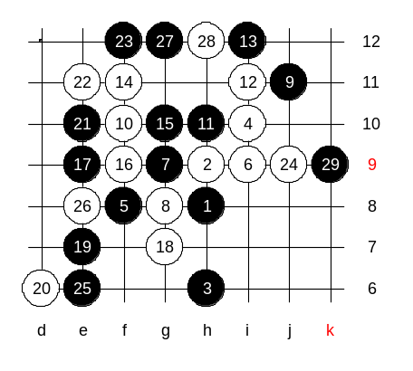
Lets try another 23rd move now. How to win?
See if anyone in this room can offer a white sure win. :)

This will be your advanced level homework.
Please find the white win here.

Over 40 students attended lesson today. Very good attendance.
The lesson is over now. Thank you all for active participation. See you all next week!

